HTTP Is Stateless
The most important thing to recall about the way the web works is that the HTTP protocol itself is stateless. Each HTTP request — in most cases, this translates to each resource (HTML page, .jpg file, style sheet, and so on) being asked for and delivered — is independent of all the others, knows nothing substantive about the identity of the client, and has no memory.
Even if you design your site with very strict one-way navigation (Page 1 leads only to Page 2, which leads only to Page 3, and so on), the HTTP protocol will never know or care that someone browsing Page 2 must have come from Page 1. You cannot set the value of a variable on Page 1 and expect it to be imported to Page 2 by the exigencies of HTTP itself. You can use HTTP to display a form, and someone can enter some information using it — but unless you employ some extra means to pass the information to another page or program, the variable will simply vanish into the ether as soon as you move to another page.

Using QueryString
A querystring is extra query information that is passed to the server in the form of name/value pairs. A querystring is appended to a URL with a question mark, “?”. If more than one pair of values is passed, then they are separated by &’s. Example:
http://www.google.com/search?hl=en&ie=UTF-8&q=my+search+query&btnG=Google+Search
“hl=en&ie=UTF-8&q=my+search+query&btnG=Google+Search” is a querystring containing four name/value pairs.

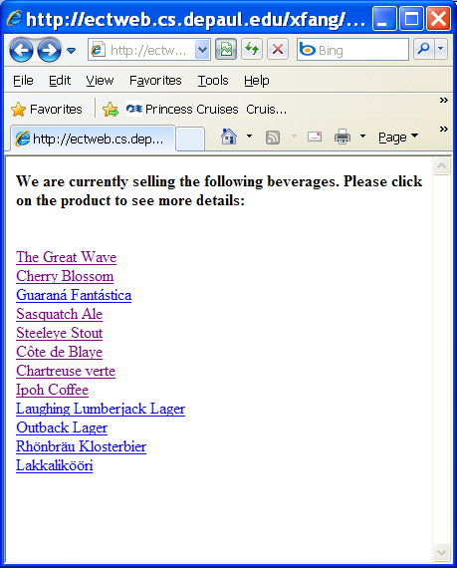  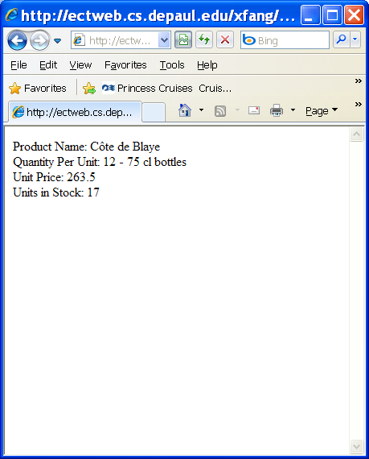 | StateManagement/BeverageCatalog..php  <HTML>  <BODY>  <h4>We are currently selling the following beverages. Please click on the product to see more details:</h4>  <br>  <div>  <?php  $conn = new COM("ADODB.Connection") or die("Cannot start ADO");  $connString= "Provider=Microsoft.Jet.OLEDB.4.0;Data Source=e:\\ectserver\\xfang\\Database\\northwind.mdb";  //creates the connection object and define the connection string  $conn->Open($connString);  $rs = $conn->Execute("SELECT ProductName, ProductID FROM Products WHERE CategoryID=1");  //opens a recordset from the connection object  while (!$rs->EOF) {  //keep looping until end of file  $fv1=$rs->Fields("ProductID");  $fv2=$rs->Fields("ProductName");  print "<a href='moredetails.php?productid=$fv1'>";  print "$fv2</a><br>";  $rs->MoveNext();  }  $rs->Close();  ?>  </div>  </Body>  </HTML>  StateManagement/moredetails.php  <html>  <body>  <?php  $productid=filter_input(INPUT_GET, "productid");  $conn = new COM("ADODB.Connection") or die("Cannot start ADO");  $connString= "Provider=Microsoft.Jet.OLEDB.4.0;Data Source=e:\\ectserver\\xfang\\Database\\Northwind.mdb";  //creates the connection object and define the connection string  $conn->Open($connString);  $selectCommand="SELECT ProductName, QuantityPerUnit, UnitPrice, UnitsInStock FROM Products WhERE ProductID=$productid;";  $rs = $conn->Execute($selectCommand);  //opens a recordset from the connection object  if (!$rs->EOF){  $ProductName=$rs->Fields("ProductName");  $QuantityPerUnit=$rs->Fields("QuantityPerUnit");  $UnitPrice=$rs->Fields("UnitPrice");  $UnitsInStock=$rs->Fields("UnitsInStock");  }  print "Product Name: $ProductName<br>";  print "Quantity Per Unit: $QuantityPerUnit<br>";  print "Unit Price: $UnitPrice<br>";  print "Units in Stock: $UnitsInStock<br>";  $rs->Close;  setcookie("productid", "$productid", time()+14400, "/xfang/StateManagement", "ectweb.cs.depaul.edu", 0);  ?>  </body>  </html>

Using Cookies

What are cookies?
- Cookies are a way to save information between visits on a client computer
- Cookies are pieces of text that are sent to a user's Web browser. Cookies can help you create shopping carts, user communities, and personalized sites.
- Cookies are text files that reside on the user’s hard drive
Look for a folder named Cookies in your Windows folder to see what cookies are already on your computer.
- While the server can send a cookie, the client must decide whether or not to accept the cookie.

Setting Cookies
The setcookie() function, used to set one cookie at a time, expects six arguments:

- Name. Holds the name of the variable that is kept in the global $_COOKIE and is accessible in subsequent scripts.
- Value. The value of the variable passed in the name parameter.
- Expiration. Sets a specific time at which the cookie value is no longer accessible. Cookies without a specific expiration time expire when the Web browser closes.
- Path. Determines for which directories the cookie is valid. If a single slash is in the path parameter, the cookie is valid for all files and directories on the Web server. If a specific directory is named, this cookie is valid only for pages within that directory.
- Domain. Cookies are valid only for the host and domain that set them. If no domain is specified, the default value is the hostname of the server that generated the cookie. The domain parameter must have at least two periods in the string in order to be valid.
- Security. If the security parameter is 1, the cookie will only be transmitted via HTTPS, which is to say, over a secure Web server.

This next line is an example of a cookie called id with a value of 55sds809892jjsj2. This particular cookie expires in four hours (the current time plus 14,400 seconds), and it is valid for any page below the document root on the domain yourdomain.com.

setcookie("id", "55sds809892jjsj2", time()+14400, "/" ,".yourdomain.com",0);

Counting time using time() function
Value | Definition
time()+60 | One minute from the current time
time()+900 | 15 minutes from the current time
time()+1800 | 30 minutes from the current time
time()+3600 | One hour from the current time
time()+14400 | Four hours from the current time
time()+43200 | 12 hours from the current time
time()+86400 | 24 hours from the current time
time()+259200 | Three days from the current time
time()+604800 | One week from the current time
time()+2592000 | 30 days from the current time

Using Cookies

To retrieve the value stored in a cookie, use the following syntax:

$_COOKIE[“cookie name”]

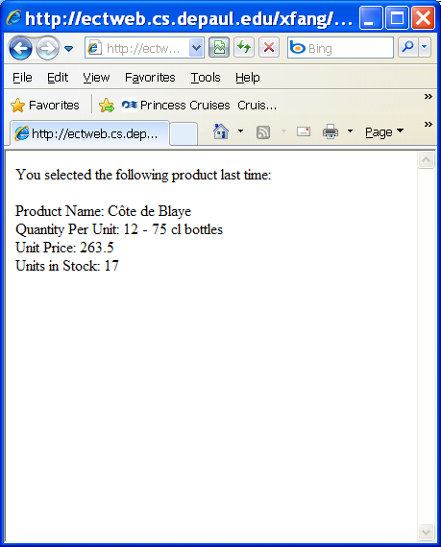 | StateManagement/checkcookie.php  <html>  <body>  <?php  if ($_COOKIE["productid"]=="")  {  print "You haven't selected any beverage yet!";  }  else  {  $productid=$_COOKIE["productid"];  $conn = new COM("ADODB.Connection") or die("Cannot start ADO");  $connString= "Provider=Microsoft.Jet.OLEDB.4.0;Data Source=e:\\ectserver\\xfang\\Database\\Northwind.mdb";  //creates the connection object and define the connection string  $conn->Open($connString);  $selectCommand="SELECT ProductName, QuantityPerUnit, UnitPrice, UnitsInStock FROM Products WhERE ProductID=$productid;";  $rs = $conn->Execute($selectCommand);  //opens a recordset from the connection object  if (!$rs->EOF){  $ProductName=$rs->Fields("ProductName");  $QuantityPerUnit=$rs->Fields("QuantityPerUnit");  $UnitPrice=$rs->Fields("UnitPrice");  $UnitsInStock=$rs->Fields("UnitsInStock");  }  print "You selected the following product last time:<p>";  print "Product Name: $ProductName<br>";  print "Quantity Per Unit: $QuantityPerUnit<br>";  print "Unit Price: $UnitPrice<br>";  print "Units in Stock: $UnitsInStock<br>";  $rs->Close;  }  ?>  </body>  </html>

Sending HTTP Headers
PHP offers the header() function, which you can use to send raw, arbitrary HTTP headers. You can use this function to roll your own cookie function if you like, but you can also use it to take advantage of any other kind of header-controlled functionality.

The syntax of header() is as simple as it can be: It takes a single string argument, which is the header to be sent.

Example: Redirection
One useful kind of HTTP header is "Location:", which can act as a redirector. Simply put a fully qualified URL after the "Location:" string, and the browser will start over again with the new address instead. Here's an example:

<?php
if (IsSet($_GET['gender']) && ($_GET['gender'] == "female"))
{
header(
"Location: http://www.example.com/secret.php");
exit;
}
?>
<HTML><HEAD><TITLE>The inclusive page</TITLE></HEAD></HTML>
<BODY>
<H3>Welcome!</H3>
We welcome anyone to this page, even men! Talk amongst yourselves.
</BODY></HTML>

If we simply enter the URL for this page (www.example.com/inclusive.php), we will see the rendering of the HTML at the bottom of the script. On the other hand, if we include the right GET argument (www.example.com/inclusive.php?gender=female), we find ourselves redirected to a different page entirely. Note that this is significantly different from selectively importing contents with the include() statement — we actually end up browsing a different URL than the one we typed in, and that new web address is what shows up in the Location or Address bar of your browser.

This kind of redirection can be useful when you want the structure of your web site to conditionally branch without having to make the user explicitly choose different links.
A redirection example:
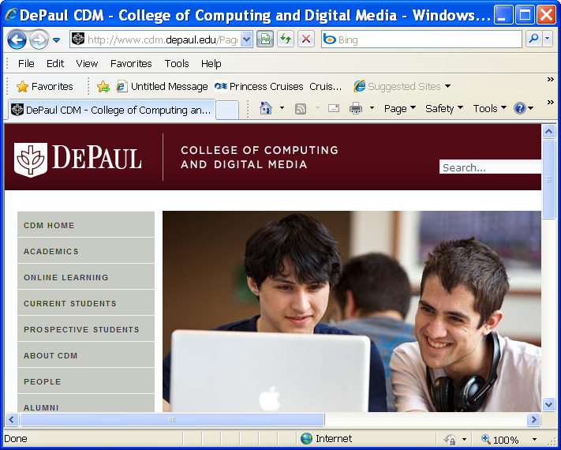 | statemanagement/phpredirect.php  <?php  header('Location:http://www.cdm.depaul.edu');  ?>

Session State
The diagram below illustrates the session state.

User#1
Session State
Session(“username”)
……
User#2
Session State
Session(“username”)
……
Page1.php
Session(“username”)
……
Page2.php
Session(“username”)
……
Page3.php
Session(“username”)
……
Sessions and Cookies
When you create a session variable, PHP does some interesting things under the hood. Essentially, it creates a file on the server containing whatever information is in the session variable, and it creates a random identifier of the session, which is stored in a cookie on the client's machine. A cookie is a small text file stored by the browser.

When you use a session variable, PHP uses the cookie identifier from the client to look up the data from the server file. Fortunately, all this is done automatically, so you don't need to worry too much about the details.

In order to use sessions, you have to follow these steps:
- Set a directory to save session information on the server
session_save_path("e:\\ectserver\\xfang\\Database");
- Start (or join) a session
<?php
session_start();
?>
The session_start() function actually performs several important tasks. First, it determines whether a session has been started for the current user, and it starts one if necessary. It also alerts the PHP engine that session variables and other session-related functions will be used within the specific script.

The session_start() code should be the very first line of your PHP program. If there is any HTML or PHP in front of this code, the session will not work correctly. Even blank spaces have been known to cause problems.
- The isset() function can be used to tell you if the session variable already has a value, returning true if the session variable has a value, or false if it does not. Typically, you'll use this technique to initialize a session variable.

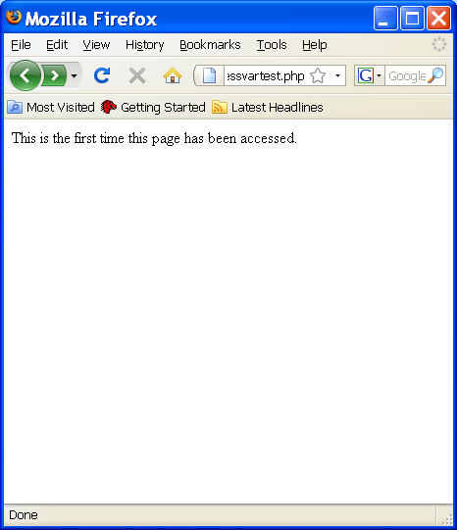  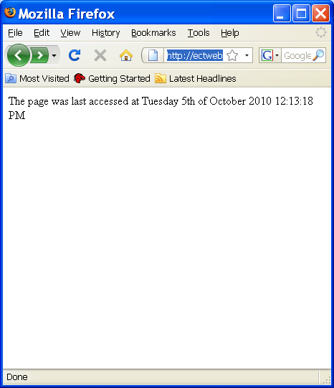  When you view a different page sess2.php:  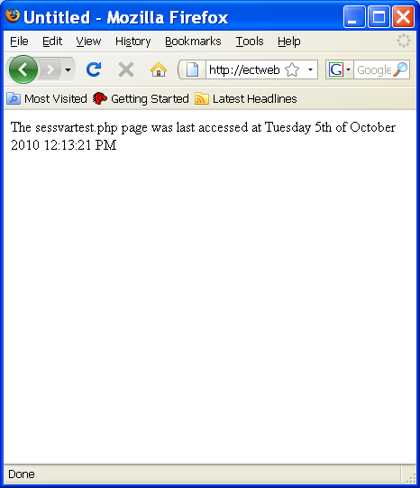 | StateManagement/sessvartest.php  <?php  session_start();  ?>  <html>  <body>  <?php  session_save_path("e:\\ectserver\\xfang\\Database");  if (isset($_SESSION["LastAccessTime"]))  {  $lastaccesstime=$_SESSION["LastAccessTime"];  print "The page was last accessed at $lastaccesstime";  }  else  {  print "This is the first time this page has been accessed. <p>";  }  $_SESSION["LastAccessTime"]=date("l jS \of F Y h:i:s A");  ?>  StateManagement/Sess2.php  <?php  session_start();  ?>  <html>  <head>  <title>Untitled</title>  </head>  <body>  <?php  $lastaccesstime=$_SESSION["LastAccessTime"];  print "The sessvartest.php page was last accessed at $lastaccesstime";  ?>  </body>  </html>
Note: you can find more information about the date() function at: http://php.net/manual/en/function.date.php

Session Function Summary

Function | Behavior
session_start() | Takes no arguments and causes PHP either to notice a session ID that has been passed to it (via a cookie or GET/POST) or to create a new session ID if none is found.  If an old session ID is found, PHP retrieves the assignments of all variables that have been registered and makes those assigned variables available as regular global variables.
session_register() | Takes a string as argument and registers the variable named by the string — for example, session_register('username'). ( Note: The variable-name string should not include the leading $.) It can also be passed an array of string arguments to register multiple variables at once. Unnecessary if using $_SESSION or $HTTP_SESSION_VARS.  The effect of registering a variable is that subsequent assignments to that variable will be preserved for future sessions. (After a script completes, the registered variables and their values are serialized and propagated in such a way that later calls to session_start() can recreate the bindings.)  If session_start() has not yet been called, session_register will implicitly call it before executing.
session_unregister() | Takes a string variable name as argument and unregisters the corresponding variable from the session. As a result, the variable binding will no longer be serialized and propagated to later pages. (The variable-name string should not include the leading $.) Unnecessary if using $_SESSION or $HTTP_SESSION_VARS.
session_is_registered() | Takes a variable-name string and tests whether a variable with a given variable name is registered in the current session, returning TRUE if so and FALSE if not. Unnecessary if using $_SESSION or $HTTP_SESSION_VARS, use isset() instead.
session_destroy() | Calling this function gets rid of all session variable information that has been stored. ( Note: A browser's session ID may still be the same after this function call.) It does not unset any variables in the current script or the session cookie.
session_unset() | Takes no arguments, and frees all variables in the session. Dangerous if using $_SESSION or $HTTP_SESSION_VARS; use unset() instead.
session_write_close() | Manually close session and release write lock on data file. Useful with frames, some clustering situations, and if you do something that might cause PHP to not realize the session has terminated (such as redirection).
session_name() | When called with no arguments, returns the current session-name string. This is usually 'PHPSESSID' by default.  When called with one string argument, session_name() sets the current session name to that string. This name is used as a key to find the session ID in cookies and GET/POST arguments — for successful retrieval, the session name must be the same as it was when the values were serialized and stored. Note that there is no reason to change the session name unless you have some need to distinguish session types that are being served by the same web server (such as in the case of multiple sites that each track sessions). The session name is reset to the default whenever a script executes, so any name change must happen in every script that uses the name, and before any other session functions are called.
session_module_name() | If given no arguments, returns the name of the module that is responsible for handling session data. This name currently defaults to 'files', meaning that session bindings are serialized and then written to files in the directory named by the function session_save_path().  If given a string argument, changes the module name to that string. (This could presumably be, for example, 'user' for a user-defined session database, but it should not be changed unless you know what you are doing.)
session_save_path() | Returns (or sets, if given an argument) the pathname of the directory to which session variable-binding files will be written (which typically defaults to /tmp on Unix systems). This directory needs to exist and have appropriate permissions for PHP to write files to it. On Windows systems, you must change this value to a valid path before using sessions!
session_id() | Takes no arguments and returns a string, which is the unique key corresponding to a particular session. If given a string argument, will set the session ID to that string.
session_regenerate_id() | Takes no arguments and sets a new session ID, setting a new cookie if necessary and returning TRUE on success or FALSE on failure. Unlike session_id(), it does not return a string with the actual new ID.
session_encode() | Returns a string encoding of the state of the current session, suitable for use by string_decode(). This can be used for saving a session for revival at some later time, such as by writing the encoded string to a file or database.
session_decode() | Takes a string encoding as produced by session_encode() and reestablishes the session state, turning session bindings into page bindings as session_start() does.
session_get_cookie_params() | Returns an array with current session cookie data: lifetime (in seconds till expiration, or 0 for no expiration), path (for which the cookie is valid), domain (for which the cookie is valid), secure (whether or not the cookie will only be sent over SSL connections). These parameters are normally set in the php.ini file, but can be changed for a single script through the session_set_cookie_params() function.
session_set_cookie_params() | Takes four arguments: int lifetime (in seconds till expiration, or 0 for no expiration), string path (for which the cookie is valid), string domain (for which the cookie is valid), boolean secure (whether or not the cookie will only be sent over SSL connections). Be sure to include a trailing slash on the path argument.

Session Configuration Variables

Php.ini Variable | Typical Value | Description
session.save_path | /tmp under Unix systems | Pathname for the server-side directory where session datafiles will be written. Must be changed for Windows systems!
session.auto_start | 0 | When 1, sessions will initialize automatically every time a script loads. When 0, no session data will be available unless there is an explicit call to either session_start() or session_register().
session.save_handler | 'files', 'user' | String that determines underlying method for saving session variable information. Changing this is not recommended for the casual user.
session.cookie_lifetime | 0 | Specifies how long session cookies take to expire and, consequently, the lifetime of a session. The default of 0 means that sessions last until the browser is closed — any other value indicates the number of seconds the session is allowed to live.
session.use_cookies | 1 | If 1, the session mechanism will attempt to propagate the session ID by setting/checking a cookie. (If the browser refuses the cookie, then GET/POST vars may be used.) If this variable is 0, no attempt to use cookies is made.

